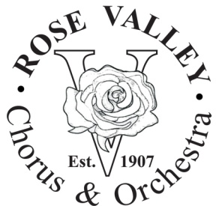“In the Spotlight”

Winter 2016

**You are cordially invited to come to the Potluck Lunch on January 10, 2016** as RVCO invites all members to kick off the New Year on **Sunday, January 10th** at Stage One. We're asking people to bring a dish - enough to feed 8 - according to the first letter of your last name: **A-H - bring sides; I-P - bring main course; Q-Z - bring dessert.** We'll start at Noon and end in time for rehearsals for The Music Man to begin.  What a great way to see old friends and meet new ones. **Save the DATE.  Everyone is invited.**



**The Music Man Cast**

Harold Hill.....................................Ray Murphy  
Marian Paroo................................Catherine Ard  
Mayor Shinn.................................Ed Nealley  
Eulalie MacKecknie Shinn.............Leslie Stanford  
Mrs. Paroo...................................Ellie Knickman  
Winthrop......................................John Hoey  
Amaryllis.....................................Isabelle Butera  
Ethel Toffelmier............................Courtney Boches  
Pick-A-Little Ladies.....................Diane Runkel, Sally Sapega, Cathy Wakefield, Julie Zaffarano  
Quartet.......................................Larry Ferdman, Michael Murphy, Mike Stadnicki, Dave Zaffarano  
Charlie Cowell.............................Al Alvarez  
Marcellus....................................Kenneth Fisher  
Zaneeta.......................................Laura Kuserk  
Tommy........................................Joshua Kurman / Nick Taddeo  
  
**Stage Directors...........................Robert Moore / Kate Nealley  
Music Director.............................Seth Gardner  
Choreographer.............................Kenneth Fisher**

RVCO is calling you to be in the Chorus:

If you are interested in singing in the chorus, please contact Ellie Knickman through e-mail eknickman@gmail.com. We would like a performer count prior to the kick-off on Sunday, January 10th.

Rehearsal Information

**Where** Stage One, Performing Arts Complex, 101 Plush Mill Rd, Wallingford, PA.

**When** Sundays (2:00-5:00pm), Mondays (7:30-10:00pm), and   
Wednesdays (7:30-10:00pm)

**Policy** Performers may not miss more than three of the rehearsals they are called for, unless receiving permission from the directors.

What do I do as a member of the Chorus

You will be expected to provide any date conflicts by the second rehearsal date (except emergencies), learn the music and the blocking. ***All performers must participate in every performance.*** In addition, performers pay annual membership dues ($25) and are expected to sell tickets and sponsorships. We are a “family” group that pulls together!!

**The Music Man – Important Dates:**

Sunday, January 10, 2016 “The Music Man” Kickoff Noon – 5 p.m.

Wednesday, April 6, 2016 Preliminary stage rehearsal school 7 p.m. - 11 p.m.

Friday, April 8, 2016               Move set to school 6 p.m. – 8:30 p.m.

Saturday, April 9, 2016 Set construction 8 a.m. - 3 p.m.

Sunday, April 10, 2016 Technical rehearsal 1 p.m. - 9 p.m.

Monday, April 11, 2016 Dress rehearsal 5 p.m. - 11 p.m.

Tuesday, April 12, 2016 Dress rehearsal 5 p.m. - 11 p.m.

Wednesday, April 13, 2016 Dress rehearsal 5 p.m. - 11 p.m.

Friday, April 15, 2016 Performance 8 p.m. 7 p.m. – 11:30 p.m.

Saturday, April 16, 2016 Performance 2 p.m. and 8 p.m. 11 a.m. – 11:30 p.m.

Wednesday, April 20, 2016 Performance 8 p.m. 7 p.m. – 11:30 p.m.

Saturday, April 23, 2016 Performance 2 p.m. and 8 p.m. 11 a.m. – 11:30 p.m.

Sunday, April 24, 2016              Performance 2 p.m. & set removal 11 a.m. - 6 p.m.

Rose Valley Chorus & Orchestra has a reputation for excellent productions.

Just as important, we have fun.

So come out and meet your old friends and make some new ones.

Carolling with RVCO

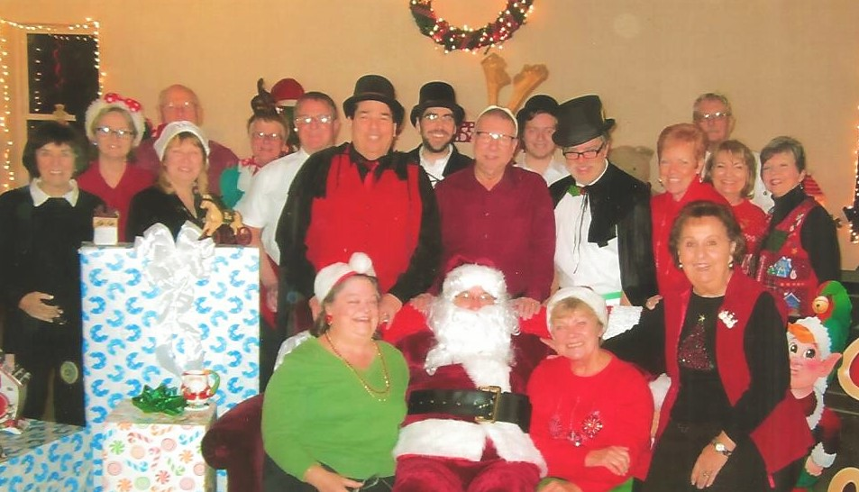

On Friday, December 4th an enthusiastic group of RVCO members welcomed Santa at the Concord Township's "Evening with Santa”.  The Concord Community Center was beautifully decorated, the children were especially good for Santa, and Frosty the Snowman (aka Wayne Jones) was loved by all. Special thanks to those who participated and to Mary Beth Dostillio who makes sure that we are invited to this annual event.  Come join us next year.

Congratulations, A Baby Girl !

Congratulations to RVCO members Al & Jeanine Loughran as they welcomed Lilly Josephine Loughran born on November 19, 2014.

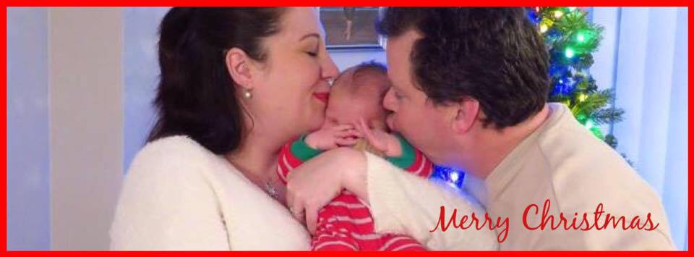

❄❄ ❄

We are excited to announce that RVCO members **Abby Clifford** and **Chris Capitolo** were married in June 2015. Congrats to the newlyweds.

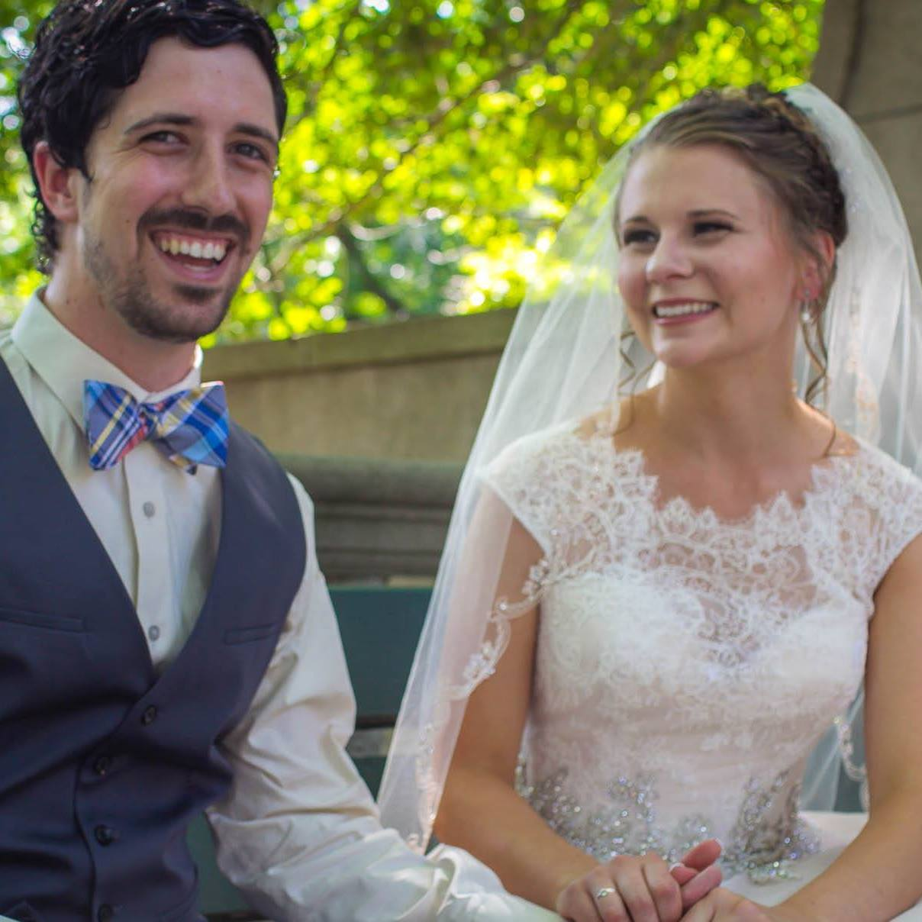

And a Wedding…

❄❄ ❄

Who’s your Frosty? So with all this warm weather, our poor Frosty has been melting away. Many thanks to Wayne Jones for being our Frosty the Snowman.

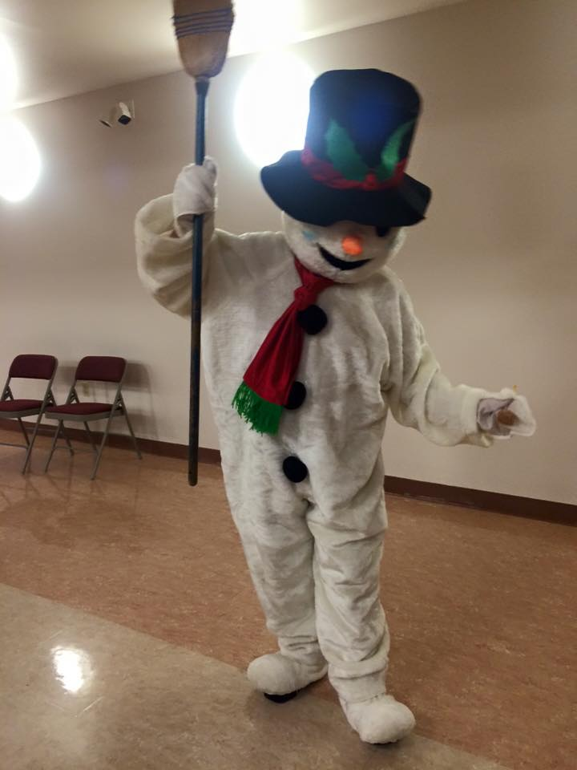

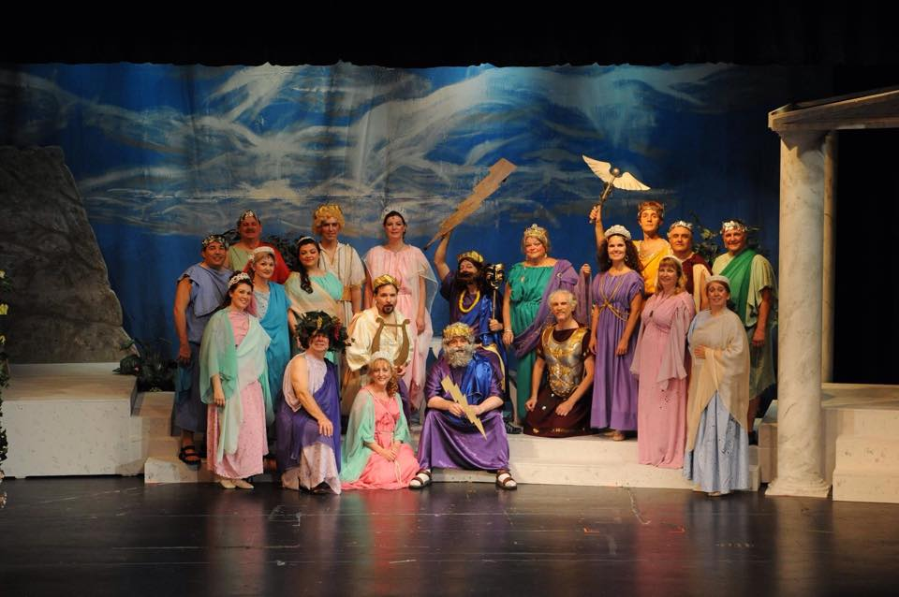

*Thespis a hit with the Gods…The recently completed Gilbert & Sullivan production with Bruce Montgomery’s music was a hit with the critics. We were able to make a donation to the Bruce Montgomery Foundation with the proceeds from the performance.*

❄❄ ❄

SHOW SELECTION COMMITTEE REPORT:

The show selection committee will be meeting after the holidays to select a show for Spring 2017 (can you believe it) and of course “IOLANTHE” was selected unanimously for Fall 2016, more details to follow. If members of RVCO would like to email me their own suggestions for next Spring's show, we would love to hear from them and present these to the SSC the beginning of January.

Please email ideas by January 5 to [robert_moore25@comcast.net](mailto:robert_moore25@comcast.net)

*Rose Valley’s Fall 2016 Production is “Iolanthe”*

Iolanthe; or The Peer and the Peri is a comic opera with music by Arthur Sullivan and libretto by W. S. Gilbert. It is one of the Savoy operas and is the seventh collaboration of the fourteen between Gilbert and Sullivan.

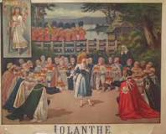

This picture is from our 1995 production of Iolanthe.

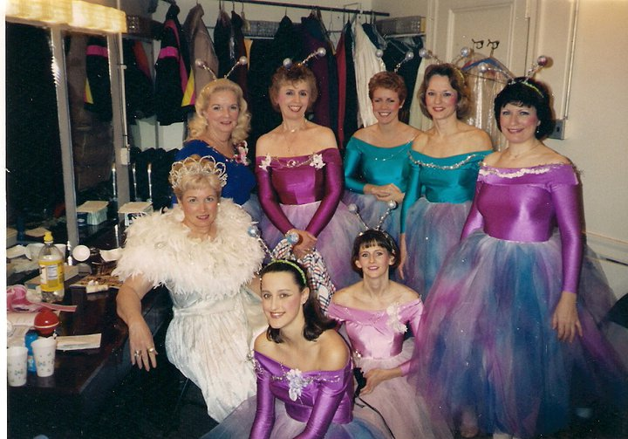

Rose Valley Annual Appeal, we need YOU

The RVCO Annual appeal is now going on. So far we have received $1,455 in donations.  Last fiscal year, we received $2,050. We certainly can use YOUR help as we try to finance some much needed maintenance and improvements at our “Firehouse” on Bortondale Road. Thank you to all for your generous donations. It is greatly appreciated.

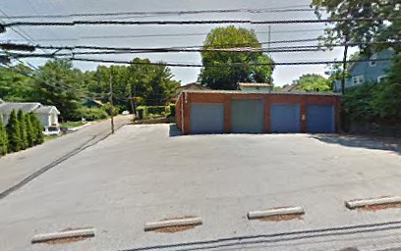

❄❄ ❄

Thank You: VMA Martial Arts Studio



Special Thank YOU to Raja Vaidya's (Mars: Thespis), as he was pleased to present RVCO with a check for $220 from the fundraising self-defense class offered by the VMA Martial Arts Studio. VMA is located in Wallingford and Springfield. Check out their website: [www.VaidyaMartialArts.com](http://www.VaidyaMartialArts.com)

RVCO Board Re-organized

We are pleased to announce that Chris Rubino has been selected to fill the open position on the RVCO Board as a Member-at-Large. Chris has done many great things for Rose Valley and will be an asset as we move forward in 2016. Our re-organized Board for the remainder of our fiscal year is listed below.

2016 Board Members:

Ed Nealley – President, Barb Matheson – Vice President,

Paula Gonzalez – Secretary, Mary Beth Dostillio – Treasurer,

At-Large Members: Robert Moore, Ken Clark, Bill DeFeo, Cathy Wakefield and Chris Rubino.

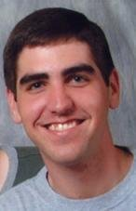

❄❄ ❄ ❄

If you would like to contribute to the RVCO newsletter by sending information about a member, please send an email to Bill DeFeo [wmjdiii@aol.com](mailto:wmjdiii@aol.com) or Paula Gonzalez [cookiesmistress@gmail.com](mailto:cookiesmistress@gmail.com)

 Rose Valley Chorus & Orchestra   
P.O. Box 414 | Media, PA 19063 | 610-565-5010  
General Info: [info@rvco.org](mailto:info@rvco.org) | Tickets: [tickets@rvco.org](mailto:tickets@rvco.org) | Website: [www.rvco.org](http://www.rvco.org)

“In the Spotlight” is a publication for the friends and members of Rose Valley Chorus & Orchestra.

Co-Editors: Paula Gonzalez and Bill DeFeo